Proposal:

**PHE Logs**

Joe Dent

SWDV-691 2019/SU2

# Problem Description

A very rare metabolic disorder called Phenylketonuria (PKU) affects 1/15,000 people world-wide. This is a genetic disorder that results in decreased metabolism of the amino acid phenylalanine. Untreated, PKU can lead to intellectual disability, seizures, behavioral problems, and mental disorders. This condition is primarily controlled by diet through careful monitoring of the food intake and frequent lab tests of blood levels of phenylalanine.

Today, patients fill out diet records by hand and email, fax, mail, or hand deliver to the dietitians. The dietitians use spreadsheets or hand calculations to measure the nutritional intake and compare to the associated blood tests for the patient to determine if any adjustments to diet are required. Typically, these patients are very young, and the dietitian needs to work through the parents or guardians to affect the food levels. Upon initial diagnosis, this can be a high-stress situation with the parents or guardians needing to track feeding events with scientific detail and accurately reporting the details.

**PHE Logs** is an application to track dietary intake of phenylalanine and provide consistent and constant communication with registered dietitians and physicians. Patients will be able to customize the list of foods to align with their normal habits to ease in capturing their meal information. An accumulative total will be provided so the patient will not consumer more than their allotted daily PHE allowance.

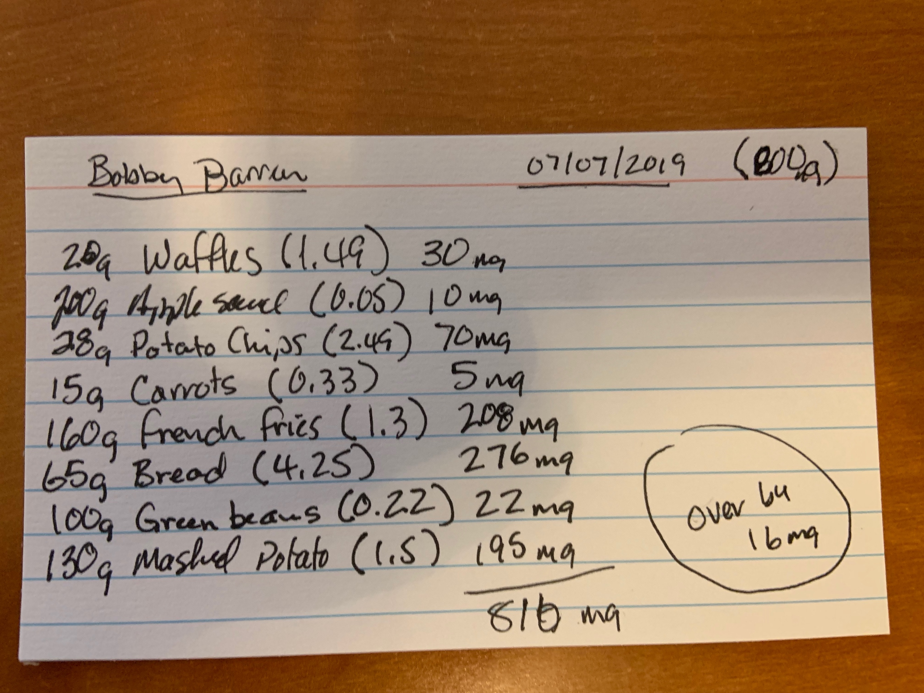Patients record their intake on diet records. These can be official copies of forms supplied by dietitians or just whatever scrap of paper the responsible party has available. Figure 1 is an example of a diet record. While this provides the basic information, it is up to the dietitian to record this in a manner that is suitable for research and proper recording for medical records. Also, note the values in parentheses, as these are the pre-defined food multiplier that is needed to provide the proper calculation of PHE intake. These number are sourced from publications that are similar to phonebooks and are not directly searchable for a given food type.

Figure – Sample Diet Record

## Benefits

### For Patients

With PHE Logs patients can easily lookup foods based on criteria or name. This is quicker and more convenient as an online service than a publication scan. Over time, patients build up documents of their most frequently consumed foods and create a cheat sheet to take with them. This replaces taking the phonebook style publication on trips and outings but leaves the patient with a limited offering of foods that can be consumed.

With very young patients, the ability to track accurate intake values is considered straight forward, as the parent or guardian can plan ahead for eating and be prepared to capture the necessary details. As the patient grows and starts attending school daily, the consistent control starts to become more challenging as school lunches, classroom parties, and after school activities all allow eating opportunities that may not be captured accurately. With PHE Logs, access to the tool can be shared among all parties allowing for quick capture of the foods eaten. With as little as five minutes training, teachers and staff can be fully prepared to support the patient’s needs.

### For Dietitians

PHE Logs provides a method of sharing data that eliminates the existing paper trail of hand written diet records. With each diet record, there is at least one hand-entered transfer of the data from the source provided. Many times, the diet records can be sent as a picture or PDF, but they can also be sent via email or text message. With RDs having multiple patients, each having multiple forms of capturing diet records, the probability of data loss is high. Using PHE Logs provides a near real-time experience with no further rekeying of the data.

When RDs gather diet records, they are looking at multiple data. There is a rather complicated calculation where the age and physical traits of the patient are measured against norms and it is determined if the patient is being nutritionally responsible.

### For Physicians

Accurate and timely data allows physicians to react to changes, capture trends, and identify areas where development is being affected. As physical exams are required every six months, allowing the physician to review the dietary trends is crucial in assessing growth patterns. Current procedures require RD to provide summary reports of patient activity. With PHE Logs, this data is readily available at all times. A Physician’s Dashboard can be created to allow the physician to see at-a-glance the progress and struggles the patient is experiencing.

# Minimum Viable Product

## Overview

PHE Logs is a web-based application that provides users secured access to diet records and food nutrition information. With the primary goal of consistent capture of diet records that can be shared between patients and an RD, focus on getting diet record data in a centrally accessible location is the MVP.

## Minimal features

Initially, RDs will register with the application identifying themselves as dietitians. They will then communicate the PHE Logs application to one or more patients for their use in tracking diet records. Patients can then also register with the application, identifying themselves as patients and picking one or more RDs to be able to access diet record data for themselves. For an MVP, the application will be web-based only, as the need to push to mobile platforms is not completely necessary to meet initial goals. As such, patients will need to have access to a web browser to create and account.

Upon first login, patients will find that they can enter food intake data immediately, based on the pre-defined food entries supplied by the USDA. This will allow patients to lookup food from the list, capture the weight they ate and the date it was eaten, defaulting to today. The PHE level within this entry will be automatically calculated based on the USDA lookup data. The patient will be able to log as many entries as needed. The only restriction on the date entry is that is cannot be in the future.

Since the USDA data set is not 100% complete, patients will also have the ability to create their own food nutrient entries. Once entered, these will display in the list of available foods just like the stock data in the application. The RD will have the ability to review and update the values stored for these entries.

At any time, the RD can review a patient’s diet records and can export the data in XLSX or CSV format for additional analysis or sharing with physicians.

## Solution Architecture

PHE Logs is to be architected as a web application utilizing APIs to provide the core data access and feature functionality. The web application shall only be focused on the activities necessary to support the user interface and manipulating the data returned from the APIs. Figure 2 provides an overview.

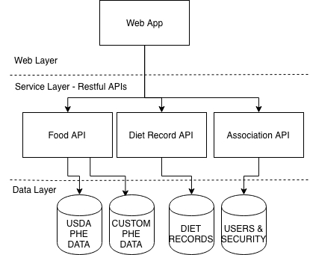

Figure 2 - MVP Architecture

The APIs will follow three (3) main segments: Food, Diet Records, Associations.

The Food API will be responsible for supplying USDA and Custom nutrition data to the UI and allowing the creation and editing of custom nutrition data for use by the patient. Since there are two separate sources of nutrition data, the Food API will handle all mixing of these multiple sources, so the UI has no need to segregate the information.

The Diet Record API will provide the capabilities to build a diet record for a given patient on a given date. This can be creating by patients, or RDs when the ability for the patient is not intact. This API will provide the CRUD operations for Diet Records.

The Association API will provide the means to register users, assign their role to the system, and allow the patient to select the users to whom access will granted to the diet records. At first, this will be a simple task assigning to the RD, and thus quick to implement for an MVP. By breaking this out into a module, the possibilities for more complex relationships can be added easily at a later time.

## Data Architecture

The data needed to support PHE logs is rather succinct, with only three categories of storage needs.

### Food Details

Food details contain the reference data for PHE within individualize food options. This data is contained in the USDAFood table. This data set is intended to allow full updates from the USDA when available. The CustomFood table is a similar table structure as USDAFood, but an additional column has been added to limit the entry to the user that created it. The keys for this food information is system generated and will be used in the diet record data stores for reference.

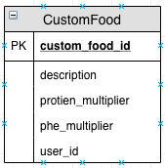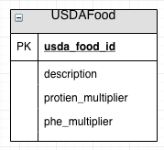

### Diet Records

Diet records are daily logs of foods consumed. This information will be entered by the patient. When the user starts a new diet record, the system shall create a new master record in the DietRecord table. Then, for each food item added to the list a new record is created in DietRecordDetail, linking back to the master DietRecord table.

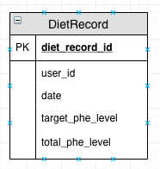 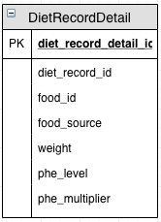

### Users

The user table stores the details about a user of the system, including their role. The associations table stores how one user relates to another, such as the RD relates to a Patient. When a patient associates an RD with their diet records, Associations is the table that holds the relationship.

